UNIONE SPORTIVA TRIESTINA NUOTO

XXIII TROFEO RIVIERA DI TRIESTE
Saturday, 1 July 2017

OPEN WATER 3KM RACE, start at 10.30

Organization: A.D.U.S. Triestina Nuoto – Passeggio S. Andrea n°. 8
34123 TRIESTE
Phone 0039/040306580
E.mail: triestinanuotomeeting@gmail.com
Web: www.triestinanuoto.com

Event Manager: Laura Sterni
Mobile : 0039/3394504642
E-mail: triestinanuotomeeting@gmail.com

Route: 3 laps of 1 km

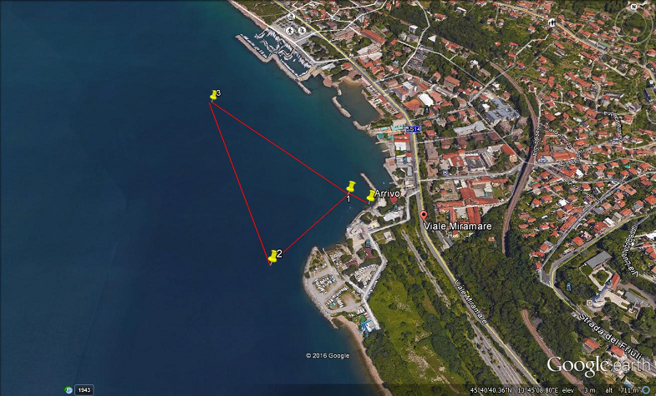

Logistic information:
Office logistics of the event and the secretariat for accreditation of athletes is located at Sailing Club of Barcola and Grignano in Viale Miramare Nr 32 , Barcola Trieste
For those arriving from Venice, after the Castle of Miramare, continue to the promenade and the Pinewood of Barcola, at the traffic lights turn to the right side.
Registration:
Entries must be received no later than 27 June Tuesday, to the email address
triestinanuotomeeting@gmail.com
The foreign teams registered with the Fina & Len rules will have to indicate the company name and the names of the athletes event participants with date of birth male/ female category and bring copy of valid not expired medical certificate along with the personal identity card
Race fees: The registration fee for each athlete / race is € 15.00.
Payment must be made by bank transfer to the account of:

Account holder: A.D.U.S. Triestina Nuoto
Bank: B.C.C. DI STARANZANO E VILLESSE
IBAN: IT55Q 08877 02202 000000343034
In the reason of transfer shall show the name of the Team and number of athletes.
Regulations:
The competition is open to athletes in good standing with the membership FINA – LEN - FIN and can participate athletes belonging to the categories: ESO A - ABSOLUTE - MASTER.
Maximum time: one hour from the arrival of the first male and female masters for 3km.
Although not covered in this Regulation shall be considered valid FIN standards for the current year.
3 Km Schedule :
- 8.30 am start crediting athletes and assignment of identification number from the judges. This number must be shown to the judge for marking. T-shirts will be delivered to all participants as gadgets
- 10.00 pre-race technical meeting with the judges
- 10:30 am departure of the race in the stretch of sea off the "Sailing Club of Barcola and Grignano" as shown in the route 3 laps of 1 Km each with the arrival hall in touching the arrival board.

At the end of race will be around at 12,30 hrs the lunch will be offered with Italian Pasta and fresh fruits
The organization reserves the right to change the route or to suspend the race if the weather conditions are adverse and prior decisions of the judge race.
Awards ceremony :
They will be awarded the top three athletes in each category male & female with medals and the first arrivals in absolute male & female with the cup.

